Separation of Organic Compounds
Abstract:
The primary objective of this experiment was to utilize two methods that is the liquid-liquid extraction and acid-base reaction to separate benzocaine, benzoic acid and 9-fluorenone. These three compounds mentioned above were mixed together in a cultured tube. It is worth noting that the methods used are essentially used in the separation of organic compounds. The vacuum filtration was used to extract each individual component in solid form. To obtain the neutral compound (9-flourenone), 2 mL of 3M sodium hydroxide was applied and two immiscible layers were formed. The lower layer containing the neutral compound was then separated and sodium sulfate used to dry the compound after weighing I obtained 46 mg. The acid compound (benzoic acid) was separated using 2 mL of 6M HCl acid and 3M NaOH and I obtained 36 mg. Lastly, 2 mL of 3M hydrochloric acid was used in the separation of the basic compound (benzocaine) and I obtained 25 mg of the compound. The melting points registered for the three individual components included 64.5-71°C, 120.5-122.5°C and 89.5-91.5°C representing 9-flourenone, benzoic acid and benzocaine respectively.
Procedure:
The procedure in this practical was got from laboratory manual from page 111-120. In this case, I weighed the following amounts 53 mg, 59 mg, and 55 mg of 9-flourenone, benzoic acid and benzocaine respectively and mixed then in the cultured tube. I then poured 2 mL of methylene chloride to the organic compounds in the cultured tube. I strictly followed the detailed steps in the laboratory manual and used a disposable plastic pipette for measuring all the liquid compounds.
Mechanism
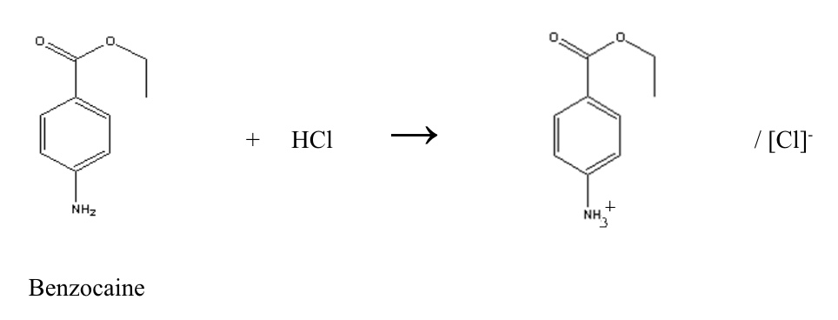
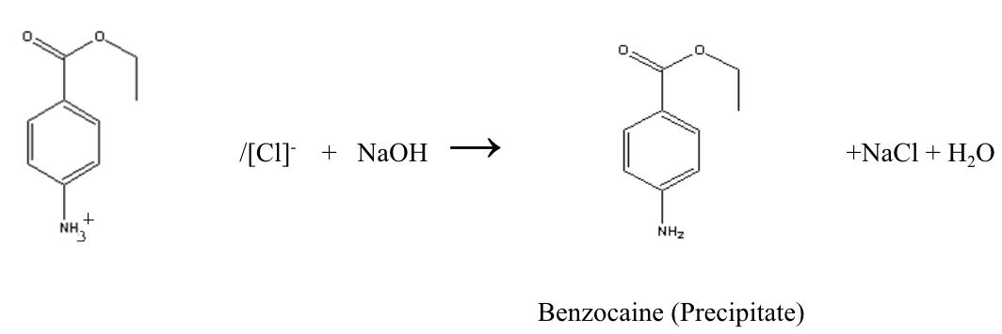
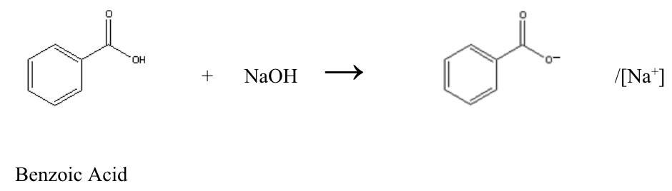
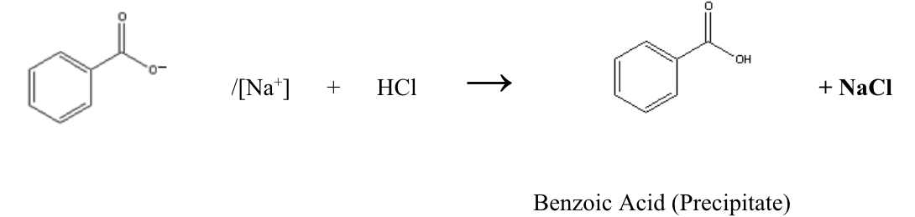

Results
Table 1. Data table
 | Mass (mg) |  |  |  | % Yield | Actual M.p (°C) | Observed M.p (°C)
 | Starting | Empty dish | Dish with compound | Recovered | % Yield | Actual M.p (°C) | Observed M.p (°C)
9-Fluorenone | 53.0 | 11,503.0 | 11,549.0 | 46.0 | 87 | ~83.5 | 64.5-71
Benzoic Acid | 59.0 | 412.0 | 448.0 | 36.0 | 61 | ~122.12 | 120.5-122.5
Benzocaine | 55.0 | 413.0 | 438.0 | 25.0 | 45 | ~88-90 | 89.5-91.5
Calculations
Recovered Mass
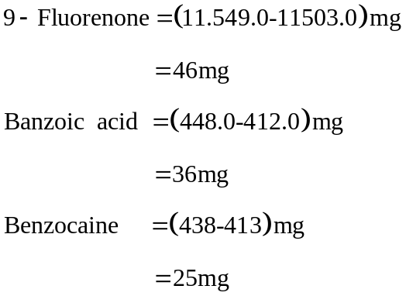
% Yield
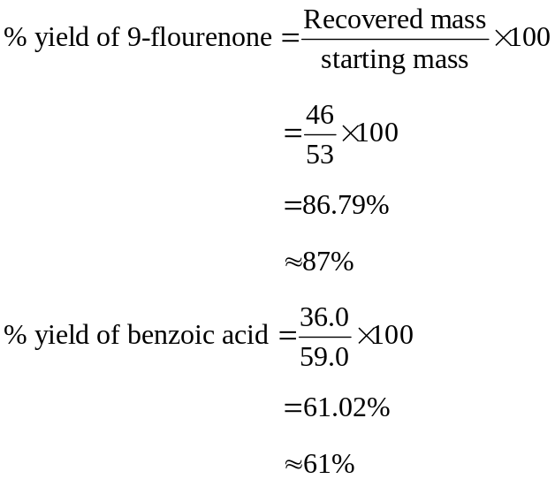
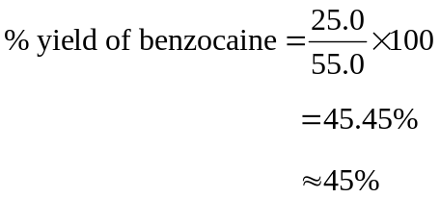
Discussion
The liquid-liquid extraction was used for extracting the individual components from the mixture. The mixture of the three organic compounds in the cultured tube were first mixed with methylene chloride. In this case, the acid-base reaction was used in the separation of the three components. Therefore, we did a 2 x 2 mL 3M hydrochloric acid extraction to separate benzocaine which is the basic component of the mixture. To start with, we poured 2mL 3M hydrochloric acid into the original mixture which formed an immiscible liquid with two layers. The aqueous top layer was composed of benzocaine while the bottom one an organic layer. The basic compound attains a positive charge after accepting a proton from the added hydrochloric acid forming a conjugate acid. This upper layer was extracted by the help of a pipette. We added 2 mL of 6M sodium hydroxide to the extracted benzocaine to precipitate it out. This addition helps in removing an extra proton on the conjugate acid as it reacts with the OH⁻ group thus precipitating out benzocaine free base as the reaction progresses. It is worth noting that this step of addition of the same amount of 3M sodium hydroxide was conducted twice. On the other hand, the bottom layer is now made up of the neutral and acid compound. Like the separation of basic component, a 2 x 2mL 3M sodium hydroxide extraction was done to separate the acid component. The added base provides a hydroxide ion which reacts with one proton from the acidic component resulting in a partially negative charge. The conjugate formed from this reaction is dissolved in the aqueous layer leaving the neutral compound in the bottom organic layer since they form immiscible layers. The upper layer is separated and the process is repeated once gain. In this regard, addition of 2mL of 6M HCl is employed to precipitate out benzoic acid. This is because the conjugate base takes a proton from the added hydrochloric acid enabling benzoic acid to be precipitated out. Finally, we added 2 mL of water, 1 mL at a time to extract the neutral compound. Waters was added for two reasons. These reasons include removal of any conjugate base and excess sodium hydroxide that was present in the tube. The organic layer containing the neutral compound was extracted and passed through sodium sulfate to dry the compound. It Is worth noting that all the precipitations in this experiment were done using vacuum filtration.
I obtained a yield of 45%, 61% and 87% corresponding to benzocaine, benzoic acid and 9-fluorenone respectively. Looking at these yields, it can be found that benzocaine and benzoic acid had relatively low yields are compared to 9-fluorenone However, in terms of the comparison between the theoretical and experimental melting pints, it can be concluded that the neutral compounds experimental melting point differs by over -10ºC from the theoretical one. I cannot deny human errors involved as we did the experiment. This is attributed to the low percentage recovery in benzoic acid and benzocaine. Some of the compound spilled out when I was mixing the three organic compounds in the culture tube. Also, a small amount of the precipitates got stuck in the flask when we were doing the extraction process. In the vacuum filtration step for the acid and basic organic compounds, some of the solids were not scrapped off the funnel and the filter paper. Some amounts got stuck on the table and the gloves I was using during the experiment leading to loss of mass in the final product hence a lower yield. The low melting point of 9-flourenone may have been caused by contamination by impurities. Besides, I may have used a small amount of the substance in determining its experimental melting point. This is attributed to the small amount extracted since 9-flourenone proved to be hard to remove the solid. Therefore, the fewer crystals may have dissolved even before the m.p was reached.
The spectrum for each compound was also carried out. The neutral compound had two functional groups of interest showing peaks at 1598 cm⁻¹ and a sharp peak ranging from 3014 to 3396 cm⁻¹ representing an amine and C-H stretches respectively. There were also two main groups for benzocaine IR spectrum: N-H group and C-O group at 3222-3454 cm⁻¹ and 1273 cm⁻¹ respectively. Lastly, the benzoic acid IR spectrum exhibited three peaks of interest. They include the peak of the carbon to carbon double bond occurring at 1453 cm⁻¹, O-H peak between 2555-2827 cm⁻¹, and a stretch representing C-O at 1000 to 1289 cm⁻¹.
On the melting point as reported from literature, benzoic acid has the highest value followed by benzocaine and lastly 9-flourenone with the lowest value. This is attributed to the resonance and polarity of these organic compounds. The low melting point in 9-flourenone can be pointed out to the double bonded oxygen and three cyclic rings in its structure which increase resonance. For benzocaine and benzoic acid, each structure possess one benzene ring but the former has an amine group which makes it to have more dipole moments compared to the later. The presence of the amine functional group makes the benzocaine more soluble in water hence forming a hydrogen bond. On the other hand, benzoic acid does not have the ability to make a hydrogen bond as it only has a carboxylic group in its structure.

